**TASK 1:**

**Simple Signal Handler: Write a C++ program that handles the SIGINT signal (Ctrl+C) gracefully by printing a custom message before exiting.**

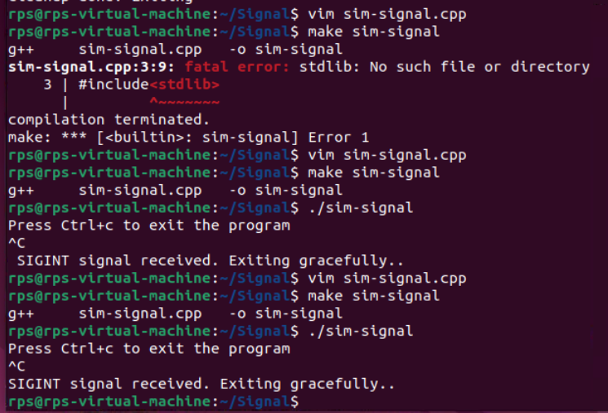

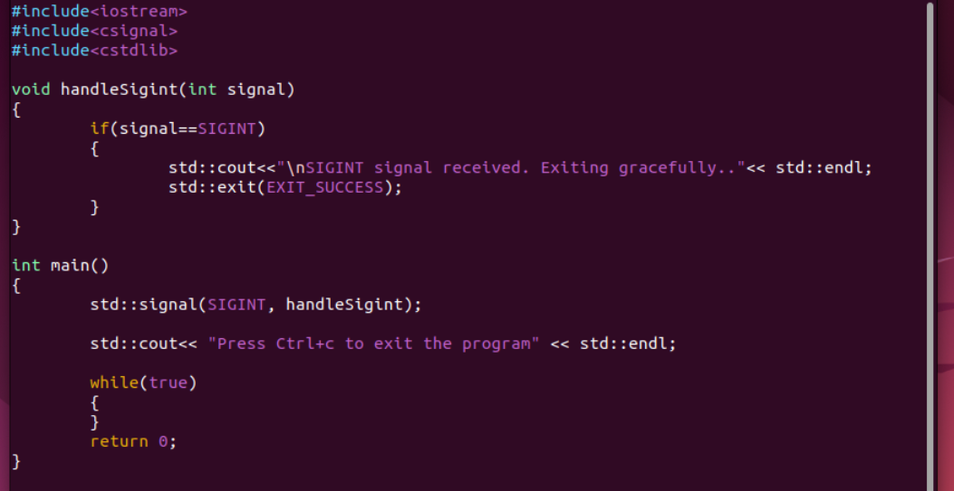

**TASK 2:**

**Multiple Signal Handling: Create a program that handles both SIGINT and SIGTERM signals, printing a different message for each.**

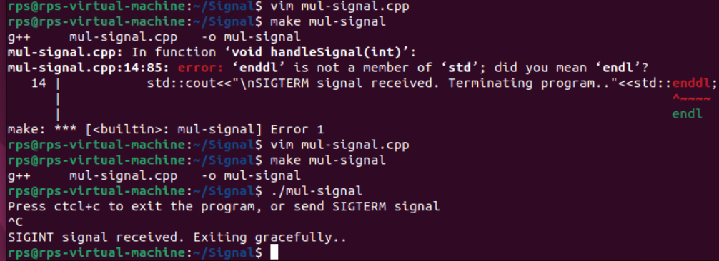

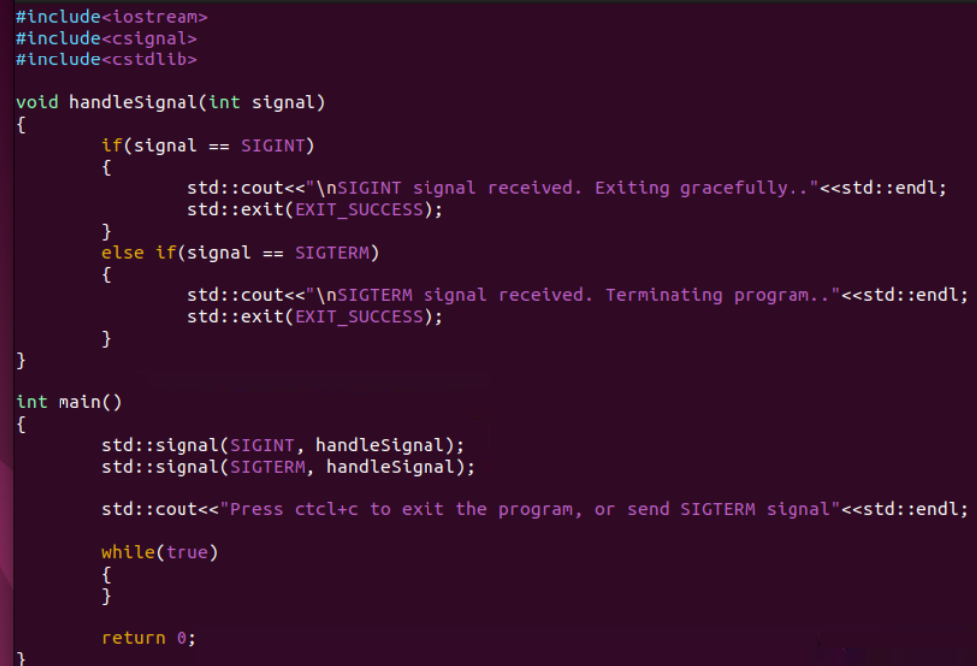

**TASK 3:**

**Ignoring Signals: Develop a program that ignores the SIGTERM signal and continues execution even after it's sent.**

**TASK 4:**

**SIGNAL - MASK**

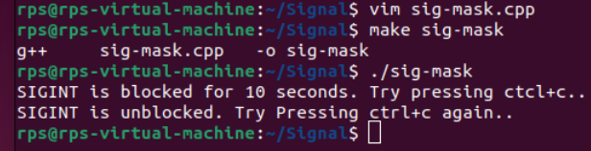

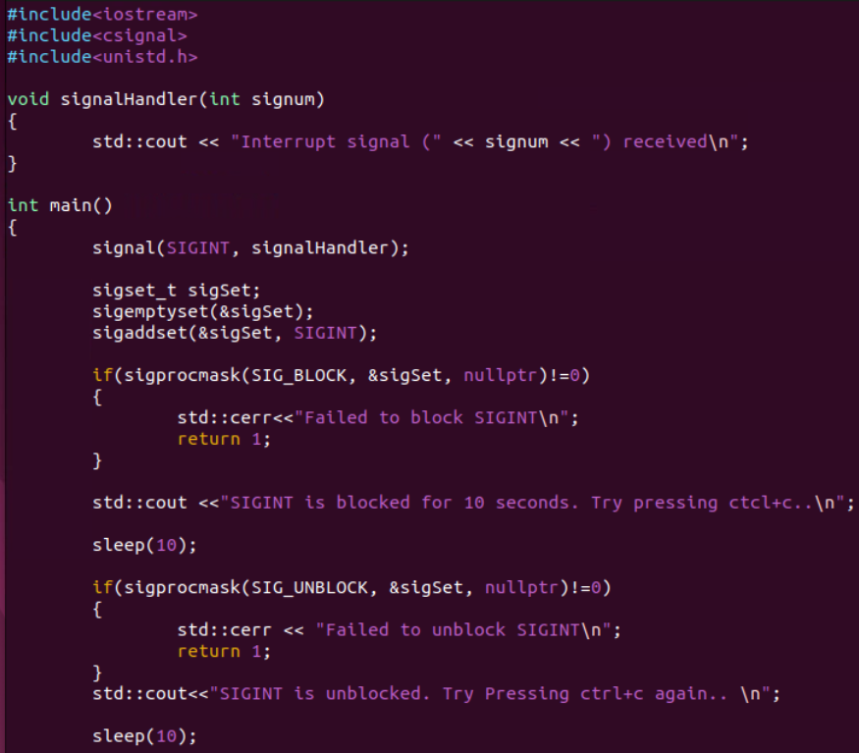



**TASK 5:**

**SIGTERM – MASK**

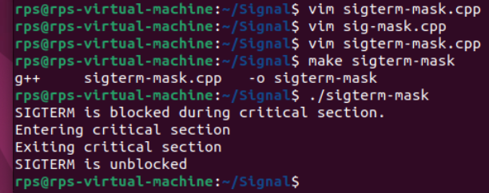

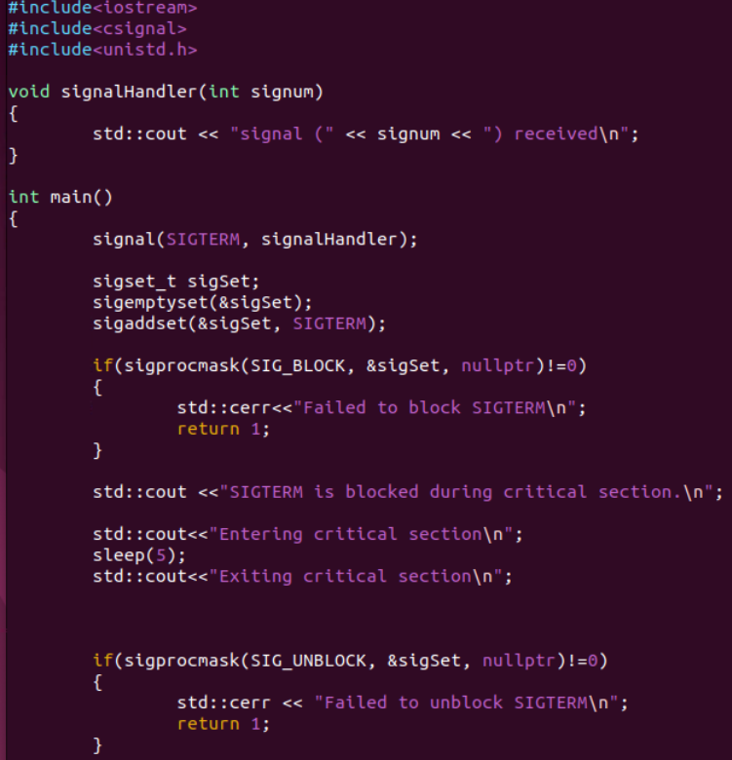

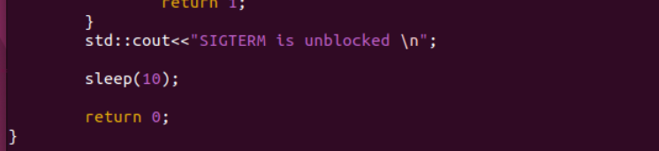

**TASK 6:**

